Velocity Chart
Sprint 1

Sprint 1 User Stories:
- US-1.1 → 8 SP (Define Scope & Success Criteria)
- US-1.2 → 8 SP (Architecture Draft + Epic Breakdown)
- US-1.3 → 7 SP (Initial Backlog + MoSCoW)
Total Planned = 23 SP
Velocity % = (Planned Story Points Completed Story Points ​) × 100

Sprint | Planned Points | Completed Points | Velocity %
1 | 23 | 18 | 78%

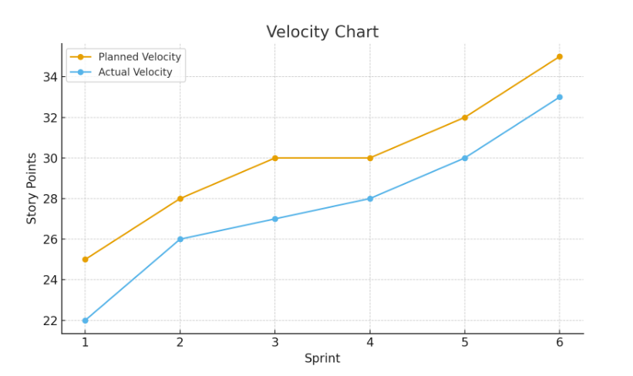

Velocity Chart
Sprint 2

Sprint 2 User Stories:
- US-2.1 → 13 SP (AI Budget Design)
- US-2.2 → 13 SP (Automated Allocation Plan/Logic)
- US-2.3 → 8 SP (Real-Time Dashboard Requirements)
Total Planned = 34 SP
Velocity % = (Planned Story Points Completed Story Points ​) × 100

Sprint | Planned Points | Completed Points | Velocity %
2 | 34 | 27 | 79%

Velocity Chart
Sprint 3

Sprint 3 User Stories:
- US-3.1 → 8 SP (User Signup/Login)
- US-3.2 → 8 SP (Logout + Session Handling)

- US-3.3 → 7 SP (Security Validation Rules)

Total Planned = 23 SP

Velocity % = (Planned Story Points Completed Story Points ​) × 100

Sprint | Planned Points | Completed Points | Velocity %
3 | 23 | 18 | 83%

Velocity Chart
Sprint 4

Sprint 4 User Stories:
- US-4.1 → 10 SP (Token-Based Authentication JWT
- US-4.2 → 8 SP (Security Policies: rate limit/validation)

- US-4.3 → 5 SP (Role-based access basics)

Total Planned = 23 SP

Velocity % = (Planned Story Points Completed Story Points ​) × 100

Sprint | Planned Points | Completed Points | Velocity %
4 | 23 | 18 | 78%

Velocity Chart
Sprint 5

Sprint 5 User Stories:
- US-5.1 → 13 SP (Expense CRUD APIs)
- US-5.2 → 8 SP (Database Connection & Schema)

- US-5.3 → 7 SP (Express Routing + Middleware)

Total Planned = 28 SP
Velocity % = (Planned Story Points Completed Story Points ​) × 100

Sprint | Planned Points | Completed Points | Velocity %
5 | 28 | 23 | 82%

Velocity Chart
Sprint 6

Sprint 6 User Stories:
- US-6.1 → 13 SP (Dashboard Layout + Navigation)

- US-6.2 → 8 SP (Expense Entry UI + Integration)

- US-6.3 → 5 SP (Charts + Filtering v1)

Total Planned = 26 SP
Velocity % = (Planned Story Points Completed Story Points ​) × 100

Sprint | Planned Points | Completed Points | Velocity %
6 | 26 | 21 | 81%

Velocity Chart
Sprint 7

Sprint 7 User Stories:
- US-7.1 → 13 SP (AI Expense Categorization Model)
- US-7.2 → 8 SP (Budget Prediction Baseline)

- US-7.3 → 5 SP (AI Integration into API/UI)

Total Planned = 26 SP

Velocity % = (Planned Story Points Completed Story Points ​) × 100

Sprint | Planned Points | Completed Points | Velocity %
7 | 26 | 20 | 77%

Velocity Chart
Sprint 8

Sprint 8 User Stories:
- US-8.1 → 8 SP (Backend Unit Testing)
- US-8.2 → 7 SP (UI Testing + Bug Fixes)

- US-8.3 → 5 SP (Feature Verification Checklist)

Total Planned = 20 SP

Velocity % = (Planned Story Points Completed Story Points ​) × 100

Sprint | Planned Points | Completed Points | Velocity %
8 | 20 | 16 | 80%

Velocity Chart
Sprint 9

Sprint 9 User Stories:
- US-9.1 → 8 SP (Deployment Plan + Setup Guide)
- US-9.2 → 5 SP (Demo Preparation + Slides)

- US-9.3 → 5 SP (Final Documentation + Review Pack

Total Planned = 18 SP

Velocity % = (Planned Story Points Completed Story Points ​) × 100

Sprint | Planned Points | Completed Points | Velocity %
9 | 18 | 14 | 78%

